Bible Study #1: Introduction to the Seven “I AM” Sayings of Jesus
Main Passages: John 6:35, 8:12, 10:7, 10:11, 11:25, 14:6, 15:1
Purpose of the Study
This study introduces the seven “I AM” sayings of Jesus recorded in John’s Gospel, exploring the rich Old Testament background of the divine name “I AM,” its theological significance in the New Testament, and the symbolic importance of the number seven in John’s writings.
Opening Prayer
“Lord God, You are the eternal ‘I AM.’ Open our eyes to see the fullness of who Jesus is as revealed in His ‘I AM’ sayings. Help us understand Your Word deeply and live in the light of Your truth. Amen.”
1. Read the Passages
- John 6:35 — “I am the bread of life.”
- John 8:12 — “I am the light of the world.”
- John 10:7 — “I am the door of the sheep.”
- John 10:11 — “I am the good shepherd.”
- John 11:25 — “I am the resurrection and the life.”
- John 14:6 — “I am the way, the truth, and the life.”
- John 15:1 — “I am the true vine.”
Questions
- What do these “I AM” statements reveal about Jesus’ identity and mission and which resonates most with you and why?
2. The Old Testament “I AM”
Divine Name Revealed:
- Exodus 3:13–14 — God reveals His name to Moses as “I AM WHO I AM” (Hebrew: ’Ehyeh Asher ’Ehyeh). This name emphasizes God’s eternal, self-existent, unchanging nature.
- God’s name Yahweh is related to this concept of “I AM” and underscores God’s covenant faithfulness and presence with His people.
God’s Self-Identification:
- In Isaiah 41:4; 43:10–13, God reaffirms His unique identity as the eternal “I AM.” The divine name asserts God’s sovereignty over time, creation, and salvation.
Questions
- Why is the divine name “I AM” so significant in the Old Testament?
- How does knowing God’s self-existence and faithfulness impact your faith?
- How does this background prepare us to understand Jesus’ use of “I AM”?
3. Jesus’ Use of “I AM” in the New Testament
Greek Language and Theology:
- In John’s Gospel, Jesus uses the Greek phrase “ἐγώ εἰμι” (ego eimi), literally “I am,” echoing the divine name of God.
- John 8:58 — Jesus declares, “Before Abraham was, I am,” provoking a strong reaction because He claims eternal, divine identity.
- The “I AM” sayings connect Jesus directly with Yahweh’s self-revelation in the OT, affirming His deity and eternal existence.
Theological Significance:
- Jesus is not merely a prophet or teacher; He identifies Himself as the eternal God made flesh (John 1:1, 14).
- Each “I AM” saying reveals an aspect of His saving work and relationship with believers (provider, guide, protector, giver of life, source of truth, and sustainer).
Questions
- How does Jesus’ use of “I AM” deepen your understanding of who He is?
- What implications does this have for worship, trust, and obedience?
4. The Number Seven in John’s Gospel and Letters
Symbolism of Seven:
- Seven is the biblical number of completeness and perfection, often representing God’s fullness and divine order.
- John uses the number seven throughout his writings: seven signs in the Gospel, seven “I AM” sayings, seven letters in Revelation, seven churches, seven spirits, and seven blessings.
Seven “I AM” Sayings:
- The seven “I AM” sayings in John form a comprehensive theological portrait of Jesus, highlighting His fullness as the divine Son of God.
- They correspond to key aspects of salvation and Christian life: sustenance, guidance, protection, leadership, resurrection, truth, and spiritual vitality.
Questions
- What does the completeness of the seven sayings reveal about Jesus?
- How can seeing Christ’s full identity affect your daily faith?
5. Kingdom Implications and Church Life
Toward One Another
- Are we, as BRBC, living out the fullness of what Jesus offers—life, truth, guidance, and sustenance—in our relationships?
- How might we deepen our teaching and discipleship around these foundational truths?
Toward Our Local Community & Wider World
- How can BRBC better communicate and demonstrate the comprehensive salvation Jesus offers through His “I AM” identity (eg light, bread, shepherd, and life) to Horsham and beyond?

Toward Families, Friends, and Relationships
- How can you share the richness of Jesus’ identity with others.
- What personal experiences reflect one or more of Jesus’ “I AM” truths?
Questions
- How can BRBC grow in reflecting the fullness of Jesus’ identity?
- How can you personally embrace all seven “I AM” aspects in your life?
- Who in your circle might need to hear these truths most?
6. Practical Action
- Study one “I AM” saying each week, reflecting on its meaning and personal application.
- Memorize John 14:6 as a summary of Jesus’ unique identity.
- Share with someone the meaning of Jesus’ divine name “I AM” and its life-changing implications.
- Pray for the Holy Spirit to reveal the fullness of Christ in BRBC and beyond.
Questions
- Which “I AM” saying challenges or encourages you most right now?
- How can you live more fully in Jesus’ identity as the Way, Truth, and Life?
Closing Scripture Meditation
John 8:58 — “Jesus said … ‘Truly, truly, I say to you, before Abraham was, I am.’”
Final Prayer
“Eternal God, You revealed Yourself to Moses as ‘I AM.’ Thank You that in Jesus, we see the fullness of Your name and nature. Help us to know Him deeply, follow Him faithfully, and proclaim Him boldly. May Brighton Road Baptist Church live in the light of these truths and be a witness of Your glory to the world. Amen.”
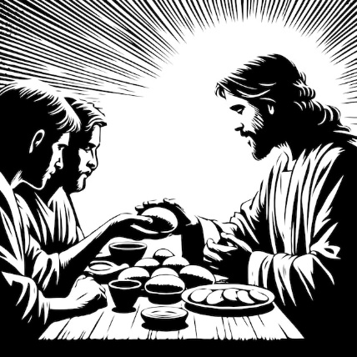
Bible Study #2: “I AM the Bread of Life”
Main Passage: John 6:35–51
Purpose of the Study
This study explores Jesus’ declaration as the Bread of Life, connecting Old Testament imagery of bread and manna, His teaching in John’s Gospel, and New Testament epistle reflections on spiritual sustenance and life in Christ.
Opening Prayer
“Lord Jesus, You are the Bread of Life who satisfies our deepest hunger. Open our eyes to see Your provision and sustain us with Your living word. Help us hunger only for You and share Your life with others. Amen.”
1. Read the Passage
John 6:35–51 — Jesus teaches that He is the Bread of Life, offering eternal sustenance beyond physical bread.
Questions
- In what ways was Jesus making such a bold claim here?
- How do you relate to hunger and thirst in your spiritual life?
2. Context and Old Testament Imagery
OT Bread Imagery:
- Manna in the Wilderness: Exodus 16 — God provides bread from heaven to sustain Israel physically.
- Bread as God’s provision: Leviticus 26:26; Deuteronomy 8:3 — Bread symbolizes God’s faithful sustenance.
- Bread in the Temple: Leviticus 24:5–9 — Showbread representing God’s fresh presence and provision.
Jesus’ claim:
- Jesus identifies Himself as the true, heavenly bread, offering eternal life (John 6:51).
- Unlike manna, which temporarily satisfied, Jesus offers lasting spiritual life.
Epistles Reflection:
- 1 Corinthians 10:16: The bread we break is communion in the body of Christ — spiritual nourishment.
- Hebrews 4:12: God’s word is living and active, sustaining the believer.
Questions
- How does Jesus’ bread differ from the manna provided to Israel?
- In what ways does Jesus sustain and satisfy us?
- How might this inform your daily spiritual “feeding”?
3. Jesus Christ: The Bread of Life
- Jesus is our true spiritual nourishment, satisfying the deepest hunger and giving eternal life.
- He invites all who come to Him to never hunger or thirst again (John 6:35).
- Jesus’ death and resurrection make this life-giving bread available to all believers.

Questions
- How have you experienced Jesus as your spiritual bread?
- What prevents you from “feeding” on Jesus daily?
- How can you help others discover Jesus as the Bread of Life?
4. Kingdom Implications and Church Life
Toward One Another
- Are we encouraging one another to feast on God’s word and presence regularly? If so, how? If not, what needs to change?
- How do we incorporate this bread or food imagery in our worship and community life?
Toward Our Local Community & Wider World
- How can BRBC be a source of spiritual nourishment in Horsham?
- Is there a link between helping those hungry spiritually and hungry physically?
Toward Families, Friends, and Relationships
- How do you model spiritual feeding for your family?
- How do you invite friends to taste the Bread of Life?
Questions
- What habits or rhythms help you “eat” this bread daily?
- How can BRBC more clearly communicate the life-giving power of Jesus?
- Who in your circle might be hungry for this bread?

5. Practical Action
- Commit to daily Bible reading and prayer as spiritual nourishment.
- Participate in communion with awareness of its meaning as “feeding” on Christ.
- Engage in acts of mercy to feed the hungry physically and spiritually.
- Share your testimony of how Jesus satisfies your deepest needs.
Questions
- What changes will you make to prioritise feeding on Christ?
- How can you invite someone to taste this bread this week?
Closing Scripture Meditation
John 6:35 — “I am the bread of life; whoever comes to me shall not hunger, and whoever believes in me shall never thirst.”

Final Prayer
“Jesus, Bread of Life, satisfy our hunger and thirst with Your presence. May we feed on You daily, grow strong in You, and share Your life with those around us. Amen.”

Bible Study #3: “I AM the Light of the World”
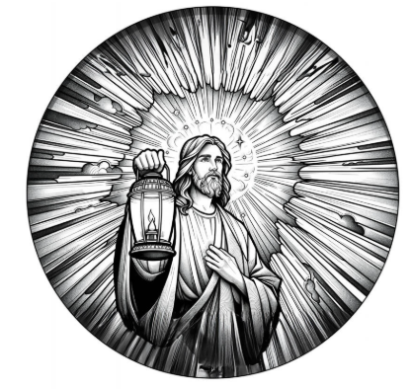
Main Passage: John 8:12; 9:1–41
Purpose of the Study
This study explores Jesus’ declaration as the Light of the World, connecting Old Testament themes of God’s light, Jesus’ teaching and miracles in John’s Gospel, and how the Epistles describe Christ as the spiritual light in our lives.
Opening Prayer
“Lord Jesus, You are the Light of the World who shines in the darkness. Illuminate our hearts, guide our steps, and help us reflect Your light to others. May Your light expose sin and lead us to truth and life. Amen.”
1. Read the Passage
John 8:12 — Jesus declares, “I am the light of the world. Whoever follows me will not walk in darkness, but will have the light of life.”
John 9:1–41 — Jesus heals a man born blind, demonstrating His power as the true light.
Questions
- What does it mean for Jesus to be the “Light of the World”?
- How does darkness function in the John 9 passage, and what is its significance?
- Where do you experience spiritual light and darkness in your life?
2. Context and Old Testament Imagery
OT Light Imagery:
- God as Light: Psalm 27:1 — The Lord is my light and my salvation.
- Light leads God’s people: Isaiah 9:2 — The people walking in darkness have seen a great light.
- God’s presence as light: Exodus 13:21 — God leads Israel as a pillar of fire by night.
- The Day of the Lord: Malachi 4:2 — The sun of righteousness shall rise with healing in its wings.
Jesus’ Claim:
- Jesus positions Himself as the divine light fulfilling OT promises of salvation and guidance.
- His healing of the blind man is a literal and symbolic revelation of spiritual light overcoming darkness.
Epistles Reflection:
- 1 John 1:5–7: God is light, and in Him is no darkness; we walk in the light.
- Ephesians 5:8–14: Live as children of light, discerning what pleases the Lord.
- 2 Corinthians 4:6: God’s light shines in our hearts to give knowledge of His glory in Christ.
Questions
- How does Jesus’ light contrast with darkness in Scripture and life?
- In what ways does Jesus’ light bring healing and transformation?
- How are we called to live as bearers of this light?
3. Jesus Christ: The Light of the World
- Jesus reveals God’s presence and truth, overcoming spiritual blindness and death.
- His incarnation brings light to a world in darkness (John 1:4–9).
- Following Jesus means leaving darkness behind and walking in His life-giving light.
Questions
- How has Jesus brought light into areas of darkness in your life?
- What practical steps help you walk in the light daily?
- How can you better reflect Jesus’ light to those around you?
- In what ways might you be hiding the light of Christ from others?
4. Kingdom Implications and Church Life
Toward One Another
- Do we encourage one another to live in the light, confessing sin openly?
- How does BRBC reflect Christ’s light in worship, teaching, fellowship, pastoral care and outreach?
Toward Our Local Community & Wider World
- How can BRBC shine as a beacon of truth and hope in Horsham?
- Are there areas of darkness or injustice where the church should/can bring light? How?
Toward Families, Friends, and Relationships
- How can you foster openness and truth in your relationships?
- Are you a source of encouragement and light to those around you?
Questions
- What obstacles hinder BRBC from fully reflecting Christ’s light?
- How can we better support one another in living transparently?
- How might your own witness increase in brightness this week?
5. Practical Action
- Commit to confessing sin and embracing God’s forgiveness regularly.
- Intentionally seek and share truth in your conversations and relationships.
- Engage in community initiatives that promote justice and hope.
- Pray for those living in spiritual or literal darkness to see the light of Christ.
Questions
- Who in your life needs to experience Jesus’ light this week?
- How can BRBC better equip and send out light-bearers into Horsham?
Closing Scripture Meditation
John 8:12 — “I am the light of the world. Whoever follows me will not walk in darkness, but will have the light of life.”
Final Prayer
“Jesus, Light of the World, shine brightly in our hearts and lives. Help Brighton Road Baptist Church to reflect Your truth and love, dispelling darkness and bringing hope to our community. Amen.”

Bible Study #4: “I AM the Door of the Sheep”
Main Passage: John 10:1–10
Purpose of the Study
This study explores Jesus’ declaration as the Door (or Gate) of the sheepfold, examining Old Testament imagery of sheep and gates, His teaching in John’s Gospel, and the Epistles’ teaching on access to God and spiritual security through Christ.
Opening Prayer
“Lord Jesus, You are the Door to life and safety. Help us to enter through You and find protection, provision, and peace. Guide us to lead others to the true Door who gives abundant life. Amen.”
1. Read the Passage
John 10:1–10 — Jesus describes Himself as the Door through which the sheep enter and find safety and abundant life.
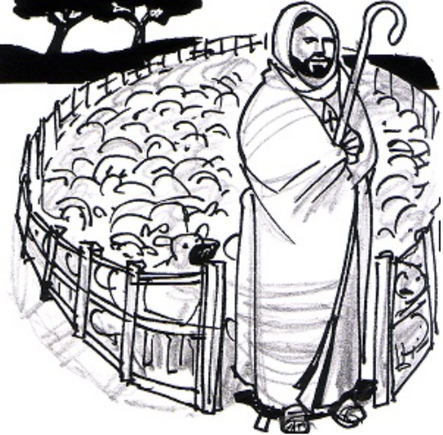
Questions
- What does Jesus mean by calling Himself the Door?
- How does this metaphor shape your understanding of access to God?
- What does “abundant life” mean to you in this context?

2. Context and Old Testament Imagery
OT Sheep and Gate Imagery:
- Sheep as God’s people: Psalm 23; Ezekiel 34 — God as shepherd caring for His flock.
- The gate of the sheepfold: Ezekiel 34:31 — God as the door or protector of His people.
- The Messiah as Shepherd: Zechariah 13:7 — Strike the shepherd, and the sheep will be scattered.
- Temple gates: Psalm 118:20 — The “gate of the Lord” as entry into God’s presence.
Jesus’ Claim:
- Jesus is the only legitimate Door, the way into the fold of God’s people. Those who enter through Him find safety and life, while others are thieves or robbers.
Epistles Reflection:
- Ephesians 2:18: Through Christ, we have access to the Father by one Spirit.
- Hebrews 10:19–22: Jesus as our great high priest opens the way into the holy place.
- 1 Peter 2:9: Believers are God’s people, called out and protected through Christ.
Questions
- How does Jesus as the Door provide security and belonging?
- What “thieves” or “robbers” threaten our spiritual lives?
- How can you ensure you are entering through the true Door daily?
3. Jesus Christ: The Door of the Sheep
- Jesus invites us to enter through Him for spiritual life and protection from harm.
- His sacrificial death and resurrection open the way for us into God’s family.
- Through Jesus, we find abundant life, not just survival but flourishing.
Questions
- How has Jesus opened the door to God for you?
- How can you help others find and enter this Door?
4. Kingdom Implications and Church Life
Toward One Another
- How do we welcome and protect one another as members of the sheepfold?
- Are we vigilant against false teachings or influences that threaten our unity? How do we recognise them?
- How do we encourage growth and flourishing in the church family?
Toward Our Local Community & Wider World
- How can BRBC be a welcoming gate for seekers in Horsham?
- What ways can we practically minister the life Jesus offers?
- How might we pray for those outside the sheepfold?
Toward Families, Friends, and Relationships
- How do you encourage spiritual belonging in your relationships?
- What barriers might keep loved ones from entering through Jesus?
Questions
- What makes BRBC a safe and life-giving “sheepfold”?
- How can we improve our openness to newcomers while guarding truth? Does truth need to be guarded?
- How might your own witness invite others through the Door?
5. Practical Action
- Reflect on your spiritual “entrance” into Christ daily through prayer and Scripture.
- Reach out to someone who needs to hear about Jesus as the Door.
- Create a welcoming environment in church and community for seekers.
- Pray for protection and growth of BRBC’s flock.
Questions
- How intentional are you about entering through Jesus daily?
- Who could you invite to experience the abundant life Jesus offers?
- What role can you play in making BRBC a welcoming gate?
Closing Scripture Meditation
John 10:9 — “I am the door. If anyone enters by me, he will be saved and will go in and out and find pasture.”
Final Prayer
“Jesus, our Door and Shepherd, lead us into Your safety and life. Help us to follow You faithfully and invite others to enter through You. May Brighton Road Baptist Church be a place of refuge and abundant life for all. Amen.”

Bible Study #5: “I AM the Good Shepherd”
Main Passage: John 10:11–18
Purpose of the Study
This study explores Jesus’ declaration as the Good Shepherd, examining Old Testament shepherd imagery, His teaching in John’s Gospel, and Epistles’ reflections on Christ’s care and sacrifice for His people.
Opening Prayer
“Lord Jesus, You are the Good Shepherd who knows, loves, and protects Your sheep. Help us to listen to Your voice, follow You faithfully, and care for one another as You care for us. Amen.”
1. Read the Passage
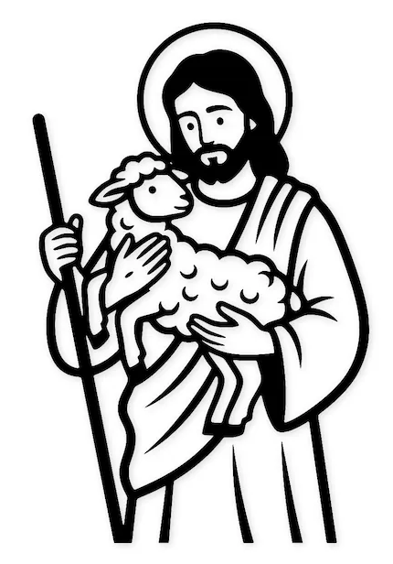
John 10:11–18 — Jesus contrasts the Good Shepherd who lays down His life for the sheep with hired hands who abandon them.
Questions
- What characteristics does Jesus highlight as a Good Shepherd?
- How does His willingness to lay down His life shape your view of Him?
- In what ways do you experience Jesus’ shepherding in your life?

2. Context and Old Testament Imagery
OT Shepherd Imagery:
- Psalm 23 — The Lord as shepherd who leads and restores.
- Ezekiel 34 — God’s condemnation of bad shepherds and promise to be the true Shepherd.
- Isaiah 40:11 — The shepherd who gently leads His flock.
- Jeremiah 23:1–4 — The promise of a righteous Branch who will shepherd God’s people.
Jesus’ Claim:
- Jesus fulfills the OT promise of the caring, sacrificial shepherd.
- He intimately knows His sheep, leads them, and lays down His life for their salvation.
Epistles Reflection:
- 1 Peter 5:2–4: Elders are called to shepherd God’s flock willingly, as examples.
- Hebrews 13:20: Jesus, the great Shepherd of the sheep, makes believers perfect.
- Ephesians 1:22–23: The church is Christ’s body, over which He is head and Shepherd.
Questions
- How do you see Jesus fulfilling OT shepherd promises?
- What does it mean to you that Jesus knows you personally as His sheep? How do you listen for His voice?
- How can church leaders model Christ’s shepherding heart?
3. Jesus Christ: The Good Shepherd
- Jesus’ shepherding is characterized by intimate knowledge, sacrificial love, and protective care.
- His death was the ultimate act of shepherding, securing salvation for His sheep.
- He also promises abundant life and ongoing guidance.
Questions
- How does Jesus’ shepherding shape your trust and obedience?
- When do you most sense His protection and guidance?
- How might we better reflect Jesus’ example of caring for others?
4. Kingdom Implications and Church Life
Toward One Another
- Are we caring for each other with the same love and commitment?
- How do we support our church leaders as they shepherd us?
- Do we create a safe, nurturing environment for spiritual growth?
Toward Our Local Community & Wider World
- How can BRBC demonstrate shepherding care to those outside the church?
- Are there vulnerable people in Horsham needing protection and guidance?
- How can we pray for Christian leaders worldwide as shepherds of their flocks?
Toward Families, Friends, and Relationships
- How do you shepherd your family in faith and love?
- Are there relationships needing restoration or deeper care?
Questions
- What would it look like for BRBC to be a community fully living out the Good Shepherd’s heart?
- How can you personally embody shepherding care this week?
- What are obstacles to effective shepherding in church life?
5. Practical Action
- Spend time listening for Jesus’ voice through prayer and Scripture.
- Encourage and support church and group leaders.
- Practice sacrificial love and care within your family and community.
- Volunteer to help care for those in need within BRBC and Horsham.
Questions
- How can you better hear and respond to Jesus’ shepherding?
- Who can you encourage or support in their role as a shepherd?
- What sacrificial step can you take to care for someone this week?
Closing Scripture Meditation
John 10:14–15 — “I am the good shepherd. I know my own and my own know me, just as the Father knows me and I know the Father; and I lay down my life for the sheep.”
Final Prayer
“Good Shepherd, lead us beside still waters and restore our souls. Help us follow You faithfully and care for one another with Your love. May Brighton Road Baptist Church be a reflection of Your shepherding heart in Horsham and beyond. Amen.”
Bible Study #6: “I AM the Resurrection and the Life”
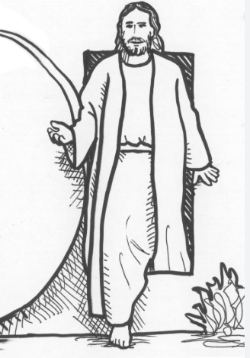
Main Passage: John 11:17–44
Purpose of the Study
This study examines Jesus’ declaration as the Resurrection and the Life, exploring Old Testament themes of resurrection and life, His teaching and miracles in John’s Gospel, and how the Epistles expand on the hope and power of resurrection in Christ.
Opening Prayer
“Lord Jesus, You are the Resurrection and the Life. In You, death has been defeated and eternal life is given. Help us to trust Your power over life and death and to live in the hope of resurrection every day. Amen.”
1. Read the Passage
John 11:17–44 — Jesus raises Lazarus from the dead, demonstrating His power over death and affirming that belief in Him leads to eternal life.
Questions
- What does Jesus mean when He says, “I am the resurrection and the life”?
- How does the raising of Lazarus reveal Jesus’ identity and mission?
- How do you personally respond to the reality of resurrection and eternal life?

2. Context and Old Testament Imagery
OT Resurrection and Life Imagery:
- Resurrection hope: Ezekiel 37:1–14 — The valley of dry bones brought to life by God’s Spirit.
- God as the giver of life: Deut. 32:39 - God kills and makes alive.
- Promise of resurrection: Isaiah 26:19 — The dead will live again.
- Life as God’s blessing: Psalm 16:10 — God will not abandon the faithful to death.
Jesus’ Claim:
- Jesus declares Himself the source of both resurrection and life — spiritual and eternal.
- His raising of Lazarus anticipates His own resurrection and the future resurrection of all believers.
Epistles Reflection:
- 1 Corinthians 15:20–22: Christ is the firstfruits of those who have died.
- Romans 6:4–5: We are united with Christ in His resurrection life.
- Philippians 3:10–11: To know Christ and the power of His resurrection.
- 1 Thessalonians 4:13–18: The hope of resurrection for believers.
Questions
- How does the Old Testament imagery deepen your understanding of resurrection?
- How can the Epistles’ teaching on resurrection encourage you in suffering or loss?
3. Jesus Christ: The Resurrection and the Life
- Jesus demonstrates authority over physical death and offers spiritual life now.
- Belief in Jesus guarantees victory over eternal death and the gift of eternal life.
- His resurrection is the foundation of Christian hope and assurance.
Questions
- How does Jesus’ resurrection power give hope in difficult times?
- How does this identity of Jesus shape your view of life and death?
- How can you live as a person transformed by resurrection life?
4. Kingdom Implications and Church Life
Toward One Another
- How do we encourage each other with the hope of resurrection?
- Do we grieve with hope and live in the power of resurrection life?
Toward Our Local Community & Wider World
- How can BRBC be a beacon of hope in a world of death and despair?
- How can we share resurrection hope with those facing loss or fear?
- How should we comfort the grieving?
Toward Families, Friends, and Relationships
- How do you bring resurrection hope to your family?
- Are there difficult losses where resurrection hope can bring comfort?
Questions
- How can BRBC more effectively witness to the reality of resurrection?
- How might your attitude to death and suffering change in light of Jesus’ claim?
5. Practical Action
- Meditate on Scripture passages about resurrection and eternal life regularly.
- Comfort and encourage those who grieve with the hope of Jesus.
- Live courageously in the power of resurrection, overcoming fear of death.
- Share your personal testimony of resurrection hope with someone this week.
Questions
- Who needs to hear about Jesus’ power over death?
- What fear or sadness can you surrender to the resurrection power of Christ?
Closing Scripture Meditation
John 11:25 — “I am the resurrection and the life. Whoever believes in me, though he die, yet shall he live.”
Final Prayer
“Jesus, our Resurrection and Life, thank You for defeating death and giving us eternal hope. Strengthen us to live boldly in Your life and to share this hope with others. May Brighton Road Baptist Church be a community of resurrection life for Horsham and beyond. Amen.”
Bible Study #7: “I AM the Way, the Truth, and the Life”

Main Passage: John 14:1–7
Purpose of the Study
This longer study explores Jesus’ profound declaration of being “the Way, the Truth, and the Life,” unpacking each aspect with Old Testament background, Jesus’ teaching in John’s Gospel, and insights from the Epistles. It invites reflection on how Jesus alone leads us to God, embodies ultimate truth, and grants eternal life.
[You may want to spread this study over a couple of sessions]
Opening Prayer
“Lord Jesus, You are the Way, the Truth, and the Life. Guide us to follow You faithfully, know Your truth deeply, and live in the fullness of Your life. Help us to trust You alone as the path to the Father. Amen.”
1. Read the Passage
John 14:1–7 — Jesus comforts His disciples, declaring Himself the only way to the Father and the source of truth and life.
Questions
- What does it mean for Jesus to be the Way, the Truth, and the Life?
- How do these three claims relate to each other?
- How does this passage shape your understanding of salvation and relationship with God?

2. The Way
OT Background:
- The Way as God’s path: Psalm 25:4–5 — Make me know your ways, O Lord; teach me your paths.
- God’s guidance: Isaiah 40:3 — Prepare the way of the Lord.
- The narrow path: Proverbs 3:5–6 — Trusting God’s way rather than our own.
Jesus’ Teaching:
- Jesus states unequivocally that He is the Way to the Father—no one comes to God except through Him (John 14:6).
- He is the divine path of reconciliation, forgiveness, and access to God.
Epistles Reflection:
- Acts 9:2: The early church was called “followers of the Way.”
- Romans 5:1–2: We have peace and access to God through Jesus Christ.
- 1 Timothy 2:5: Jesus is the one mediator between God and humanity.
Questions
- How have you experienced Jesus as the Way in your spiritual journey?
- Are there areas where you struggle to trust His path?
- How can BRBC better lead others to walk in Jesus’ way daily?

3. The Truth
OT Background:
- God’s truth: Psalm 119:160 — The sum of your word is truth.
- God’s faithfulness: Isaiah 65:16 — God is the God of truth.
- Wisdom and knowledge: Proverbs 3:7 — Walking in God’s truth brings life.
Jesus’ Teaching:
- Jesus is not just a teacher of truth but the embodiment of truth (John 14:6).
- He reveals God’s reality fully and accurately, countering deception and error.
Epistles Reflection:
- John 1:14: The Word (Jesus) full of grace and truth.
- Ephesians 4:21: Disciples are taught in accordance with truth in Jesus.
- 1 John 5:20: Jesus is the true God and eternal life.
Questions
- Pilate asked – “What is Truth?” How would you answer?
- How does knowing Jesus as Truth affect your understanding of (i) life, (ii) the Scriptures and (iii) faith?
- What challenges do you face in discerning and living in truth today?
- How can BRBC encourage a culture grounded in the truth of Christ?
- How do we hold on to truth in an age of relativism?
4. The Life
OT Background:
- God as giver of life: Genesis 2:7 — God breathes life into humanity.
- Eternal life promised: Daniel 12:2 — The resurrection to everlasting life.
- Life in God’s presence: Psalm 16:11 — In your presence is fullness of joy; at your right hand are pleasures forevermore.
Jesus’ Teaching:
- Jesus offers not only physical life but eternal, abundant life (John 10:10).
- This life is life in intimate relationship with God, starting now and continuing forever.
Epistles Reflection:
- Romans 6:23: The gift of God is eternal life in Christ Jesus our Lord.
- 1 John 5:11–12: Eternal life is found only in the Son of God.
- Colossians 3:4: Our life is hidden with Christ in God.
Questions
- How has Jesus’ gift of life changed your perspective on living and dying?
- In what ways do you experience this “life” now?
- How can BRBC help nurture and celebrate life in Christ?

5. Kingdom Implications and Church Life
Toward One Another
- Are we walking together in Jesus’ way, truth, and life as a church family?
- How do we encourage integrity and authenticity grounded in Christ’s truth?
- Do we celebrate life in all its fullness within our fellowship?
Toward Our Local Community & Wider World
- How can BRBC guide seekers to find Jesus as the only way to the Father?
- In what ways can we expose falsehood and confusion with the truth of Christ?
- How do we share the hope of eternal life with those facing despair?
Toward Families, Friends, and Relationships
- How do you live out the way, truth, and life in your closest relationships?
- Are there relationships where walking in truth or life needs healing?
Questions
- How can BRBC deepen its witness to Jesus’ exclusive claims?
- How can you personally be a clearer reflection of the way, truth, and life?
- What steps can you take to invite others to know Jesus in these ways?

6. Practical Action
- Commit to daily following Jesus’ way through Scripture and prayer.
- Pursue truth in teaching, conversation, and personal integrity.
- Celebrate and share the life Jesus gives in your relationships and community.
- Invite someone to explore Jesus as the Way, Truth, and Life with you.
Questions
- What’s one practical way you can walk more closely with Jesus this week?
- How will you stand for truth in your daily life?
- Who might you invite to experience the life Jesus offers?
Closing Scripture Meditation
John 14:6 — “I am the way, and the truth, and the life. No one comes to the Father except through me.”
Final Prayer
“Jesus, our Way, our Truth, and our Life, guide us to follow You faithfully, live in Your truth, and enjoy Your life fully. Help Brighton Road Baptist Church to embody and proclaim Your exclusive love and salvation. Amen.”

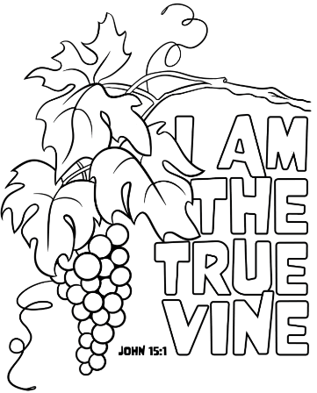
Bible Study #8: “I AM the True Vine”
Main Passage: John 15:1–8
Purpose of the Study
This study explores Jesus’ declaration as the True Vine, focusing on Old Testament vine imagery, His teaching on abiding in Him, and how the Epistles deepen understanding of living connected to Christ for spiritual fruitfulness.
Opening Prayer
“Lord Jesus, You are the True Vine. Teach us to remain in You daily, drawing life and strength from Your presence. Help us bear lasting fruit for Your glory and serve one another in love. Amen.”
1. Read the Passage
John 15:1–8 — Jesus describes Himself as the True Vine and calls His followers to remain in Him to bear fruit.
Questions
- What does it mean to “abide” or “remain” in Jesus?
- Why is fruitfulness tied to remaining in the vine?
- What kinds of fruit might Jesus be referring to?
2. Context and Old Testament Imagery
OT Vine Imagery:
- Israel as God’s vine:
  - Psalm 80:8–16 — Israel planted as a vine by God’s hand, expected to flourish.
  - Isaiah 5:1–7 — The Song of the Vineyard, describing Israel as a vine that failed to produce good fruit, leading to God’s judgment.
  - Jeremiah 2:21 — Israel called a “degenerate” or “corrupt, wild vine” that produces fruit for itself.
  - Ezekiel 15 and 17 — The vine used as a symbol of judgment and restoration.
- God as the vinedresser:
  - Isaiah 27:2–6 — God protects and prunes His vineyard to bring restoration and fruitfulness.
  - Psalm 80:15 — The vinedresser cares for the vine to keep it alive and fruitful.
Jesus’ Teaching:
- Jesus identifies Himself as the True Vine, in contrast to Israel’s failure, fulfilling God’s plan for fruitfulness.
- Believers are the branches who must remain in Him to bear fruit; apart from Him, they can do nothing (John 15:4–5).
- The Father is the vinedresser who prunes branches to promote greater fruitfulness (John 15:1,2).
Epistles Reflection:
- Galatians 5:22–23: The Spirit’s fruit is evidence of abiding in Christ.
- Colossians 2:6–7: Continue to live in Christ, rooted and built up.
- Ephesians 3:17: Christ dwelling in believers strengthens their inner being.
- 1 John 2:24–27: Abiding in Christ leads to remaining in truth and love.
Questions
- How does the Old Testament’s use of the vine illustrate God’s expectations and Israel’s failure?
- What does the role of the Father as vinedresser teach us about God’s care and discipline?
3. Jesus Christ: The True Vine
- Jesus is the source of all spiritual life and fruitfulness for believers.
- Abiding in Him is not optional but essential; apart from Him, we are spiritually dead or unfruitful.
- His pruning, though sometimes painful, is an act of love designed to deepen our faith and increase fruitfulness.
Questions
- How do you experience abiding in Jesus day by day?
- What “pruning” has God allowed in your life, and how has it helped you grow?
4. Kingdom Implications and Church Life
Toward One Another
- How do we encourage each other to remain in Christ and bear good fruit?
- Are we willing to allow God’s pruning as a community for growth and holiness?
Toward Our Local Community & Wider World
- How can BRBC’s fruitfulness impact Horsham practically and spiritually?
- How might we pray for spiritual fruit among local churches and believers worldwide?
Questions
- What fruit do you see BRBC producing, and where is growth needed?
- How can you personally contribute to the church’s spiritual fruitfulness?
5. Practical Action
- Commit to daily abiding in Christ through Scripture, prayer, and worship.
- Reflect regularly on the “fruit” in your life (Galatians 5:22-23).
- Embrace God’s pruning lovingly, seeking growth even in difficulty.
- Serve others as an expression of fruitfulness connected to the Vine.
Questions
- What daily rhythms help you remain connected to Jesus?
- How will you respond to God’s pruning or correction in your life?
Closing Scripture Meditation
John 15:5 — “I am the vine; you are the branches. Whoever abides in me and I in him, he it is that bears much fruit, for apart from me you can do nothing.”
Final Prayer
“True Vine, nourish us with Your life and love. Teach us to remain in You, bear lasting fruit, and serve others in Your strength. May Brighton Road Baptist Church thrive as a community deeply rooted in You, bearing fruit for Horsham and beyond. Amen.”

