HCT CHRISTMAS CAROL SERVICE

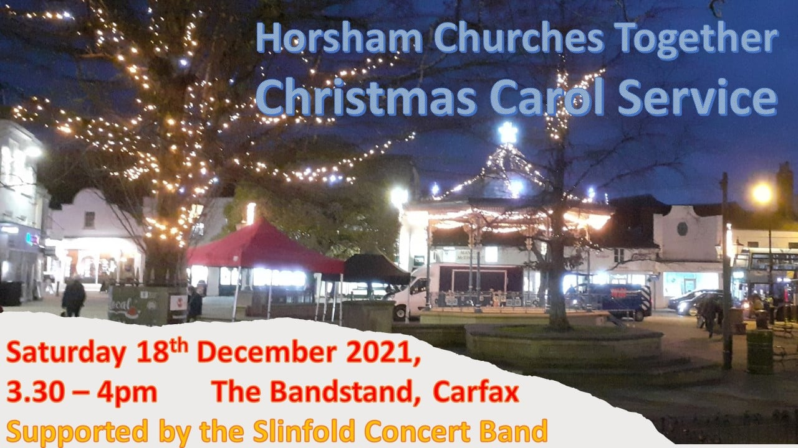

OUTDOOR CHRISTMAS CAROLS IN THE TOWN CENTRE

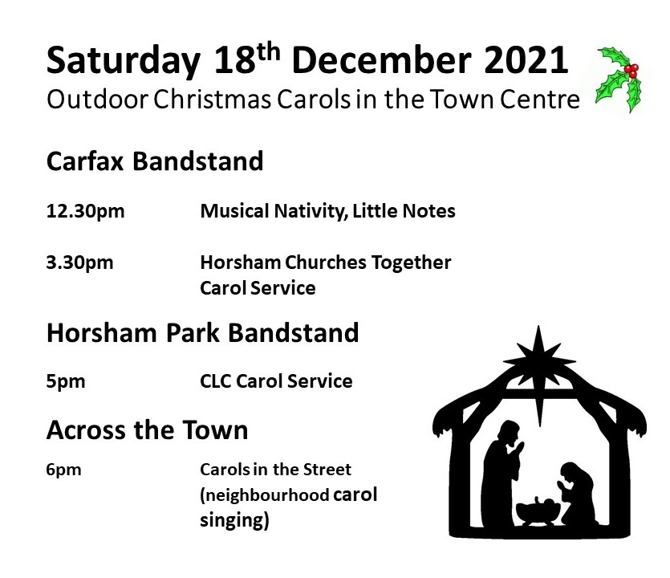
As we are facing renewed challenges and anxiety as COVID influences our preparations for Christmas, we want to encourage you to share some information about some events in the town centre where you can sing carols out of doors.

LITTLE NOTES MUSICAL NATIVITY

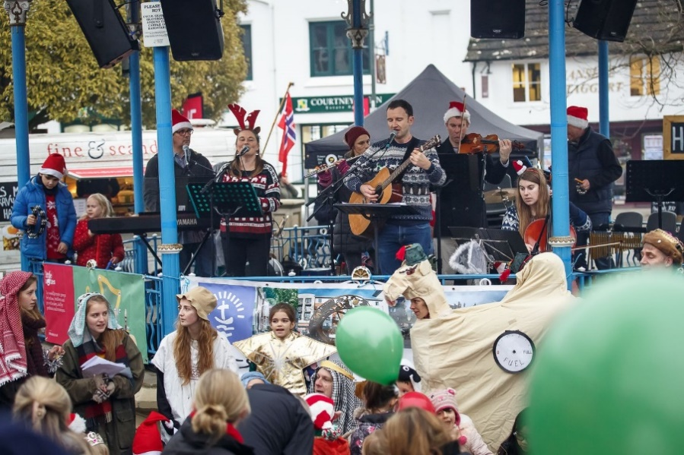

Join the Little Notes Christmas Band for a fun and festive Christmas Singalong at Horsham's Carfax Bandstand. This is an outdoor celebration of Christmas aimed at under 5's and their families. Festive attire is very welcome as are angels, shepherds, cows, sheep and donkeys!

HORSHAM QUAKER MEETING VOLUNTEER RESIDENT FRIEND

Horsham Quaker Meeting is now looking for a resident friend to live in the cottage attached to our meeting house and volunteer certain duties to help with the running of the premises and the meetings for worship. Full details and application form available here:
https://www.horshamquakers.org.uk/residentfriend

CAROLS IN THE STREET

We’re hearing that a number of people across the town have picked up on the idea of getting together with a few neighbours to sing carols and enjoy each others company in the street on Saturday 18th December at 6pm. Why not get a few friends together and be part of this Christmas celebration. Carols in the Street is a local initiative put forward by Angela, who lives in north Horsham, who has a heart to build on the sense of community which she has experienced during lockdown by promoting and encouraging a moment of Christmas praise across the town this year. Last year she simply invited a few neighbours to bring a candle and join her in the street to sing some Christmas carols and get to know each other better. In the light of growing Covid uncertainties this is a simple way to encourage Christian’s to share the true meaning of Christmas ‘out of doors’.

If you’d like to know more or have contact with Angela, drop me a line at Richard.jackson@horshamct.org.uk and we’ll put you in touch.

ONE GOOD FRIDAY HORSHAM 2022

The Steering Group for One Good Friday Horsham met last week to talk about our plans to deliver the Wintershall Passion Play in the centre of Horsham in April 2022. Most of you will know that the Passion Play was due to be performed in 2020 and had to be cancelled because of lockdown. In order to produce the play in 2022, we would need to start an intensive rehearsal schedule from the beginning of January. Along with one or two other challenges, the increased uncertainties about the impact of the pandemic have led the Steering Group to the reluctant decision to postpone the 2022 event. There is still a huge enthusiasm for this event across the town, and the team are now looking at the viability of planning to deliver the Passion Play on Good Friday, 2023. Please pray for the team as deliberations continue.

HOME FOR GOOD: CHARITY SUPPORTING FOSTERING AND ADOPTION IN CHRISTIAN FAMILIES – FUNDING FROM WSCC

Working with Graham and Sarah White (St Mary’s) I was delighted to meet last week with Billie Jo O’Leary, regional representative of Home for Good, a charity dedicated to finding a home for every child who needs one by resourcing a network of people, churches and local movements across the UK. Home for Good work to raise awareness of the needs of vulnerable children and young people, inspiring individuals to explore fostering and adoption and equipping churches to understand and provide support to caring families. In a huge answer to prayer, Home for Good have just been able to enter into a ground breaking agreement with West Sussex County Council to provide part funding for a local worker with a brief to engage with Churches to promote, encourage and support Christian families with a heart for fostering and adoption. Please promote www.homeforgood.org.uk, especially to families or individuals who might have a heart for issues relating to fostering and adoption. For more information about this developing work in Horsham or contact with other local Christians who are passionate about this work, drop me an email at Richard.jackson@horshamct.org.uk

COMMUNITY CHRISTMAS LUNCHES

Is your Church offering lunches or social events for people in your community? Liz Burt from Horsham District Council is collating opportunities for people to link up with community events. If you would like to use HDC to promote your event, Liz would love to hear from you. You can contact her on 01403 215517 or email Liz.Burt@horsham.gov.uk

HORSHAM COMMUNITY FRIDGE CHURCH POP-UPS

We are delighted that a Horsham Community Fridge Church Pop-Ups rota will start in the New Year, on Saturdays 10am to 11am at churches in Roffey, Southwater and Horsham. Publicity for each host church will be separate at first, to enable them to build up a local client base and become familiar with hosting a Pop-Up Community Fridge.

Horsham Community Fridge are seeking more volunteers to help as a Food Collector, Fridge Monitor or Pop-Up Helper. Food handling training is provided through a 1.5-hour online course, you can just help at a specific venue or join the general rota. For more information please email: volunteers@faredivide.org.uk

Volunteer registration form: https://forms.gle/uhhQRrK3HuYD9eDw5

Horsham Community Fridge is currently open at The Wellbeing Hub, The Forum, Horsham (was Benson bed shop) on Tuesdays 10-11am and Thursdays 1-2pm.
https://faredivide.org.uk/horsham-community-fridge-project/

Sussex Green Hub includes a Church Pop-Up Fridge on Saturday 18th December and 29th January from 10am - 4pm at The United Reformed Church, Horsham, together with Horsham Repair Café, Transition Horsham and Horsham Eco Churches with volunteers repairing, refilling bottles, recycling, reducing carbon footprint, reflecting and serving refreshments.
https://www.sussexgreenliving.co.uk/sussex-green-hub/

CHRISTMAS ADVERTS FOR CHURCHES

In the past, HCT has taken out a full page spread in the County Times to advertise Christmas Services. As we move out of lockdown, attendance arrangements still vary considerably between Churches. Most Churches are now fully open for services, some are still using virtual options for some services, and some a blend of the two. The recent increase of Covid cases in our area has introduced further uncertainty and caused some to review their risk assessments and consider reintroducing options to manage attendance at live services. In view of the rather complex and changing message, we have decided not to take out the shared advertising option this year, so we would encourage each other to use local means of advertising our services, including the HCT website.

RECYCLING SINGLE USE PLASTIC AND OTHER COMMUNITY PROJECTS

Conservation and Climate Change are the source of real anxiety to people of all ages. What difference can you make? Last weekend I was excited to meet up with Karen Park and the team of Sussex Green Living when they came together at the URC in Springfield Road. The Hub brings together lots of local groups who are inspiring people, including Churches, to make simple changes to our behaviour, reduce our carbon footprint and improve the environment. It was really exciting to see and hear how many projects are running in our own town and District to promote recycling and better living. Karen was there to talk to visitors about EcoChurch, and there are lots of other community groups helping to educate and encourage improvement in Horsham. I was particularly excited to meet the ‘Wombles’ – the team who are busy promoting the recycling of single use plastics which cannot currently be put in the domestic recycling bins. From toothpaste tubes to cheese wrappers, we are all throwing things away all sorts of things which can be recycled. The full list of items and how to recycle them is at Single-use plastic recycling | Sussex Green Living. I want to encourage you to think about whether your Church could promote this kind of recycling in your local community by becoming a collection site for single use plastic. Some of this recycling actually benefits charities in the town including Springboard. Get in touch with Karen Park to talk about how you can take simple steps to become an Eco Church, and while you’re at it, put 18th December 2021 in your diary – that’s the date of the next Sussex Green Living Hub at the URC where you can meet Karen and the team. Please promote the Sussex Green Living project by encouraging people to drop in on the 18th, perhaps their way to the HCT Christmas Carol Service!

HOLY TRINITY CHURCH CAROLS

Holy Trinity Church is holding a carol concert on Saturday 18th December from 5pm-7pm. There will be Christmas decorations, carols for children and adults, refreshments, and a fire pit outdoors.

HORSHAM ECO CHURCHES NEWS
This month’s Eco Churches news can be found below:
https://mailchi.mp/ab788aa03cb3/horsham-eco-churches-fairtrade-market-5688680?e=f9fcf6ffc4

HORSHAM MATTERS CHRISTMAS APPEAL

Like the client who came to us for support on Monday who has a child, is pregnant with her second child, whose relationship has broken down and has lost her job, many people are having to make hard decisions this Christmas; having to choose between paying the bills, keeping the heating on or eating.

At Horsham Matters we have a range of services to support those who are struggling financially which include Horsham Foodbank, our Toy Bank, budgeting & debt advice services, gas/electric vouchers as well as help for those either facing eviction or being housed from homelessness.

Your donations are crucial in enabling our charity to support so many local people. This Christmas we are asking you to give a little so that we can put the ‘happy’ into our clients’ Christmases and continue to support them as they need it into the new year.

How can you make a donation?

You can make a bank transfer to:
Bank account name: Horsham Matters Ltd
CAF Bank
Sort Code: 40-52-40
Account Number: 00021472
Reference: Christmasappeal

You can go on-line to:
https://www.justgiving.com/campaign/horshammattersatchristmas

Alternatively please send a cheque payable to Horsham Matters to our address at Micah House, Blatchford Road, Horsham, RH13 5QR or drop it into our Charity shop in Redkiln Close RH13 5QL

YMCA LOVE IN A BOX CHRISTMAS APPEAL
Make up a shoe box of gifts for a young person staying in supported housing over Christmas age appropriate for 16–25-year-olds. You can drop off your box at Horsham Y Centre by 21st December. More information and ideas of what to include are attached.

TURNING TIDES CHRISTMAS APPEAL

If you have no place to call home - Christmas is the hardest time of year.
This year a record number of local people have no safe place to call home.
In the last 12 months, Turning Tides supported over 900 people. As the economic impact of Covid continues and the cost of living rises - the homeless emergency is growing across West Sussex.
Turning Tides wants to ensure no one faces the trauma of homelessness alone.
They need your help.
Your donation helps them to provide the warmth, safety & support everyone deserves.
Please see the attached notice for more information.

ANCHOR COUNSELLING

If problems are starting to overwhelm you, now may be the right time to seek support from us….
Anchor Counselling offers confidential, compassionate and professional counselling in Horsham. We have been affiliated to Horsham Churches Together for over 10years. Our service is provided by fully qualified, experienced, registered and accredited Counsellors, offering short or long-term work with clients, depending on your need. Daytime sessions are available to adults 18+. Where appropriate, subsidized fees may be available. We have Covid-19 safety policy guidelines in place now that we have in person counselling sessions in Horsham.

We are here to help!
Contact us today by phone or email:

07971 582 718
contact@anchor-counselling.org.uk
www.anchor-counselling.org.uk

