THIS WEEK’S NOTICES INCLUDE
- News
- Are You a Forum Delegate?
- Fegans/Together in Horsham Project Update: 30th June 2022
- Urgent Donation Request From The Horsham District Foodbank
- Horsham Matters Open Day – 14th July
- Horsham Matters Connecting Café: New Venue
- Family Support Workers in Horsham
- Refugee Week: 20th-26th June 2022 (Churches Together in Britain and Ireland)
- Coordinating our response to refugees arriving in Horsham

- Employment Opportunities
- Horsham Matters – Advocacy Assistant

- Events
- Into the Light - Horsham Chamber Choir
- Riding Lights Theatre Company – ‘My Place… Somewhere to belong’
- The History of England and Wales in 2.2 Hours! 9th July 2022 (Charity Fundraiser)

- Volunteering Opportunities
- Horsham Matters
- YMCA Downslink Group

- Newsletters
- Anchor Ministries

ARE YOU A FORUM DELEGATE?

Each of our 32 member Churches is encouraged to designate two members of the Church congregation as ‘Forum Delegates’ to attend our quarterly Forum meetings. These are opportunities to meet and pray together, and where we share views about areas and activities where the Churches can work together as the visible Body of Christ across the town and villages.
It’s become clear that during lockdown a number of forum members have changed. If you have been invited to represent your Church at the HCT Forum, could you drop as an email at admin@horshamct.org.uk, including a contact telephone number and the Church you represent. This will help us to ensure that we get the right information to you at the right time.
The next meeting of the Forum is on Thursday 21st July, and will also be held at Trafalgar Road Baptist Church. This meeting is our Annual General Meeting. We will gather from 7pm, with the meeting starting at 7.30pm.

FEGANS/TOGETHER IN HORSHAM PROJECT UPDATE: 30TH JUNE 2022

We are inviting Forum members to represent their Church at a meeting on 30th June 2022 at St Mary’s Church, to meet Sarah Wallis, Project Manager of the Together in Horsham or Fegans Project, which provides counselling for children and young people in schools. You will learn how the benefit of this service has been felt by local schools. Funding from local Churches has been critical to this project, and this meeting is part of the process of looking at our place in the funding for next year. Places are limited but if you would like to be there, please email Richard.Jackson@HorshamCT.org.uk who will send you more information.

URGENT DONATION REQUEST FROM THE HORSHAM DISTRICT FOODBANK

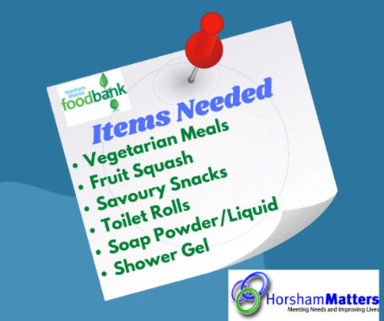
There is an ongoing urgent need for specific contributions to the Horsham District foodbank provided by Horsham Matters. The needs change from week to week, so please check the list of items which are URGENTLY required on the Horsham Foodbank website.

Donations can be made Monday-Friday 9-5pm at our Redkiln Close office.

HORSHAM MATTERS OPEN DAY – 14TH JULY

You are warmly encouraged to drop into the Horsham Matters Open Day on 14th July between 10am and 4pm. Drop into the Foodbank at Redkiln Way to find out more about the many ways in which the dedicated team work to support the local community.

You can download a poster for this event from the News page on our website.

HORSHAM MATTERS CONNECTING CAFÉ

Building on the tremendous success of our community Connecting Café at St Andrews Church, we have decided to expand this fantastic provision into another location in the centre of town.
From Thursday, 7th July, Lavinia House, will be the home of our Thursday Connecting Café which will run from 11:30-13:30. It will follow the same style of our current popular set up at St Andrews Church. offering hot meal choices along with sandwiches and simple snacks. Our Eat; Share; Donate! model will also continue, so you can buy a meal, but you can also donate a meal too!
We want the Connecting Café to be a place where people feel welcome to enjoy a meal together and meet new people in their community.

FAMILY SUPPORT WORKERS – HORSHAM TEAM!

The Family Support Workers have been active across Sussex for many years, and it’s great to see their team growing. They have now appointed two new practitioners to cover the Horsham area – Dominique Short covers the Central Horsham area, with the North Horsham District villages being covered by Penny Rae. This brings FSW to 20 practitioners, doing tremendous work to support families across East and West Sussex. You can find out more about the work of the team and find contact details for all the practitioners at www.familysupportwork.org/

REFUGEE WEEK 2022

This week, 20th – 26th June, is being marked by Churches Together in Britain and Ireland as Refugee Week. The Sunday at the end of the week is designated as Sanctuary Sunday to give expression through prayer and witness to the centrality of sanctuary and hospitality to the stranger in the Christian call to love our neighbours. At its heart, this work is about connecting people, locally and globally, with respect for the dignity of every human person as made in the image and likeness of God.
It goes without saying that this is a topical theme for us here in Horsham and across the world.
For more information and resources see https://ctbi.org.uk/sanctuary-resource-for-refugee-week/

COORDINATING OUR RESPONSE TO REFUGEES ARRIVING FROM UKRAINE

It’s not easy to keep track of numbers across Horsham District, but at every drop-in centre and teaching session it becomes clear that the number of new arrivals continues to grow. We are continuing to work with the Horsham Refugee Support Group to provide a coordinated response to refugees from Ukraine who are arriving in our community.
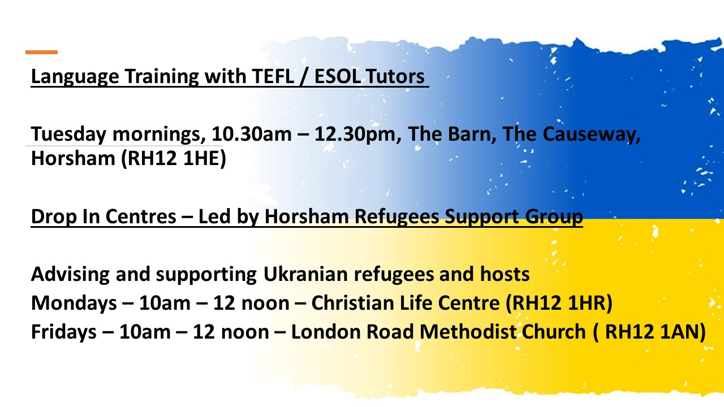
St Mary’s are also providing a Friday afternoon family and teens drop in. For more info email vicar@horshamstmarys.org.uk.

HORSHAM MATTERS – ADVOCACY ASSISTANT

Horsham Matters are recruiting a part time Advocacy Assistant to work with their clients on the Horsham area. The role is 20 hours per week and offers £12.50 per hour. Full information and online application are available on the Indeed website

INTO THE LIGHT – HORSHAM CHAMBER CHOIR

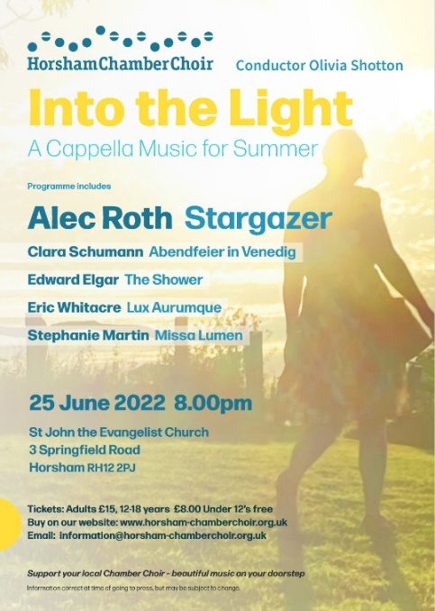
A Cappella Music for Summer
We are delighted to announce our fourth concert of the 2022 season, Into the Light, a varied, truly spine-tingling and profoundly atmospheric programme of shorter unaccompanied music from both classical and internationally renowned contemporary composers. Themed around the summer sky, light and stars, this beautiful collection of pieces takes the listener on a journey from night-time into daytime.

Includes:
Alec Roth: Stargazer
Clara Schumann: Abendfeier in Venedig
Edward Elgar: The Shower (from a poem by Henry Vaughan)
Eric Whitacre: Lux Aurumque
Stephanie Martin: Missa Lumen

Date: June 25th 2022
Time: 8pm
Venue: St John the Evangelist Church, 3 Springfield Road, Horsham RH12 2PJ

RIDING LIGHTS THEATRE COMPANY – ‘MY PLACE… SOMEWHERE TO BELONG’

The Riding Lights Theatre Company will be at St Mary’s Church, Horsham on Thursday 5th July at 7.30pm, with their drama ‘My Place.. Somewhere to Belong’. Presented in support of Christian charity Home For Good, My Place shares the interwoven stories of four individuals as they journey through the care system in a deeply moving and insightful performance. You can view a trailer here.

The play promotes a better understanding of the experience of children and young people living in care. It is suitable for teenagers and adults but is not recommended for children under 11 years.

Tickets are £10 (or £8 for concessions – under 16 or unwaged).
This play is particularly suitable for: safeguarding officers, youth and children’s workers, young people, teachers and all those interested in fostering and adoption. An e-flyer is available. Hard copies (A5, A4 and A3 posters) are available from Sarah White (sarah@whitex.net)
Book tickets through the Riding Lights Theatre Company online here.

THE HISTORY OF ENGLAND AND WALES IN 2.2 HOURS!
Supporting Southwater Youth Project and Siblings Together

This is a free event at the United Reformed Church, Saturday 9th July, doors open at 5.30pm for a 6pm start, but it is also a fundraiser for two great charities, including the Southwater Youth Project. A light supper is provided but please bring your own drinks!
‘Ken Eglington will be connecting the dots in the story of England and Wales in a digestible way with plenty of drama, humour, pictures, breaks and some controversy.’

VOLUNTEERING OPPORTUNITIES – HORSHAM MATTERS
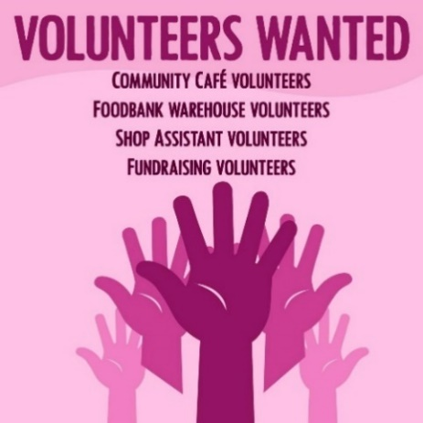
Want to work with great people and make a real difference in your local community?
Then become one of our valued volunteers. We’re currently on the lookout for volunteers across many positions within Horsham Matters, including Community Café, Foodbank Warehouse, shop assistants, and fundraising support volunteers.

For more information and how to get involved, get in touch at info@horsham-matters.org.uk or give us a call 0300 124 0204

YMCA DOWNSLINK GROUP – VOLUNTEER WITH US!

We are seeking compassionate, understanding people of faith to become Volunteer Chaplains!
If you:
- Are a good listener
- Have a heart for helping young people
- Have a couple hours to give on a Thursday evening
- Like cooking meals with others and sitting round a table to eat with them
Then we would love to hear from you!
Our volunteer Chaplains spend one evening every few weeks cooking a simple meal and sitting round a table to eat with vulnerable young people who would otherwise be homeless. Their listening presence connects the young people with their community, and they feel valued and heard. A simple meal brings togetherness and creates a homely atmosphere that many of us take for granted. They are also there to talk about faith or pray, should a young person ask it.
“Chaplaincy makes me feel like I have a place to go at the end of the day… where I can unpack my feelings and thoughts a bit, socialise if I want to. It’s a fairly open space where people can get to know each other… and overall, it makes me feel pretty happy, content and just accepted, and that’s good.” Resident.
“It’s very rewarding to cook for the young people and to get to know them. The obvious benefits they are getting from the social opportunity of eating together is lovely to see.” Volunteer
Interested? To find out more and apply, contact Samantha Burton, YMCA West Sussex Chaplain: samantha.burton@ymcadlg.org / 07557855779

ANCHOR MINISTRIES NEWSLETTER
(anchorministries.co.uk)
News from Wally Fahrer, Anchor Ministries

As the summer approaches and the days lengthen, we look forward to some kind of normality returning. But the dangers haven’t all passed, and some things will never be the same. These past two years have taken a toll on all of us – on our strength and reserves – and they leave us aware of the loss all around us. We long for this to be all over and for the pandemic to be a thing of the past!
Even the strongest of us – and sometimes especially the strongest – can feel worn down and exhausted after all we have been through. That weariness can have a negative effect on our mental health. You may find yourself desperate for a holiday, wanting to be alone, or avoiding others who have needs, because you sense inside that your emotional reserves are at a low ebb. Maybe this is true for someone you know. If this begins to affect your ability to function, and you feel you need more than coffee with a friend, you may need professional help and counselling, Don’t put it off because you cannot afford to pay for it.
The good news is that Anchor Ministries stands ready to help. As a charity we can provide a subsidy for counselling sessions regardless of a person’s faith. Key to our mission is a service which provides counselling with caring professionals who understand how you feel. Check out our website to discover the resources that are available.
Update. Already this year, Anchor Ministries has received a number of financial gifts to continue our mission. This has allowed us to subsidise clients who cannot afford the full cost of counselling. We have also been able to fund additional costs for PPE and safeguarding allowing our counsellors to create a safer environment to begin to meet face to face again. No one should have to be alone with a mental health struggle. And we will do all we can to prevent that. Your prayers and support enable us to continue with that mission.
“Blessed are those who mourn for they shall be comforted.” Matt 5:4
During these last two years, some of us have lost loved ones. Some of us have lost jobs or businesses. For most of us the pandemic has meant loss of income and now we are facing an unprecedented cost of living increase. And while we don’t live in the Ukraine, we do see the images on the news every day! There is so much loss! So, what does our faith have to tell us about times like these?
It is interesting that the Lord doesn’t scold those who mourn. He doesn’t tell us not to mourn. Rather, Jesus pronounces a blessing on those who mourn! And that blessing is the promise of comfort. What is comfort? Ultimately, comfort is a special kind of love and compassion given at the place of pain. Think of hugging a child after they have fallen down in the mud and hurt themselves. Getting mud on your own clothing is not important compared to comforting the child! And they don’t need to be scolded for being careless. What they need is love and acceptance in the midst of their pain.
That is what comfort is. It is a special love in the midst of pain. It is also a love mixed with hope. It accepts the pain of the loss but holds out for a better future. As the Psalms remind us, weeping does endure for the night, but joy comes in the morning (Ps 30:5). Comfort makes no demands on the mourner to believe this, but instead it holds out hope on their behalf. It is compassion, not pity. It is like meeting someone in a subway under the road. They have started their journey, lost sight of their entry and are unsure of the exit. Then you arrive from the other side. Your very presence says, “yes, there is an exit, and you will get there. You will get through this.”
In times like these we can be a people who offer comfort to those who have experienced loss. But we may need to experience it ourselves. Paul spoke of our God as “the Father of compassion and the God of all comfort” (II Cor. 1:3). In our private times with God and in our corporate worship, we need to be encouraged to ask God for the comfort we need to face the losses we have experienced. And we can ask for more of his presence so that we can comfort others we know who have experienced loss.
May you know God’s comfort overflowing in your lives so you can offer it to others who need it!

